RENOUNCING KOREAN NATIONALITY

Being a Korean National means that a person was born to at least one Korean parent. Each country has its own citizenship laws based on its own policy and the Republic of Korea (ROK) bases its nationality on the parents’ nationality.

Nationality is defined as the legal status of belonging to a particular nation.

AM I A ROK NATIONAL?

According to the ROK Nationality Act, a ROK national is --
- any person whose father or mother is a national of the ROK at the time of a person’s birth;
- at the time of birth, his or her father or mother was to be a national of the ROK.

HOW CAN I RENOUNCE?

A dual citizen may renounce their Korean nationality only when he or she is domiciled abroad. The individual must apply in person by visiting the head of a diplomatic mission (either the Korean Embassy or the Consulate General) that has jurisdiction over their place of residence and submitting the required forms.

- A person who is 15 years of age or older must visit and apply in person. (Parents cannot apply on behalf of the person)

- A male must apply before March 31 of the year he turns 18.

AM I SUBJECT TO CONSCRIPTION?

A male who wants to report after April 1 of the year he turns 18 must submit a document (issued by the Military Manpower Administration) proving that he has performed, been exempted, or joined the second national service:
- Military service certificate; OR
- resident registration copy (must be an original issued within 3 months)

More information is available online at:
https://down.mofa.go.kr/us-chicago-en/brd/m_4830/view.do?seq=761414

Hours of Operation

Legal Assistance
By Appointment Only

Will Appointments
Please call to complete Will worksheet BEFORE you make a will appointment!
By Appointment Only

Powers of Attorney/Notaries
Mon-Thur 0900-1600
Fri 0900-1400
Closed every second Friday

You can complete power of attorney and read information at https://aflegalassistance.law.af.mil

51 FW/JA
OPC 3 BOX 2067
APO AP 96266-2067
Building 938, Osan AB
DSN 784-4131 or commercial 0505-784-4131

RENOUNCING KOREAN NATIONALITY (FOR MINORS)

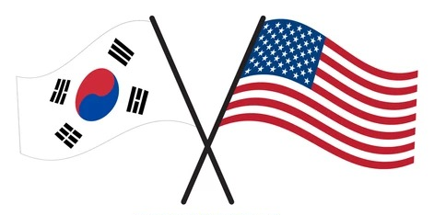

51st Fighter Wing

LEGAL OFFICE

Current as of August 2025

